Deactivate Voice Service Over Cable

Version Control:

Use Case Name: |  | Deactivate Voice Service
Use Case Owner: |  | Sumit Borade
Current Version |  | 0.2
Use Case Version History
Modified Date | Version |  | Modified By | Change Description
July 8, 2009 | 0.1 |  | Tom Schnarr | Initial Version
August 26,2009 | 0.2 |  | Sumit Borade | Updated for adding the reply step and removed steps not relevant for SMP

Brief Description:
This use case describes the process by which a YouSee subscriber’s broadband and optional voice service is deactivated.

The use case is written from the perspective of the SMP provisioning solution.

Related Documents
- YouSee SMP SOW2Architecture Requirements Document
- YouSee SMP SOW2 Business Requirements Document
- Voice over Cable Use Case Activation
- Cisco BACC TC Specification
- Cisco Subscriber Manager TC Specifications
- Cisco BTS TC Specification

Related Use Cases

Pre-Conditions
- Subscriber is an active broadband over cable subscriber.
- Subscriber may also have voice over cable services.

Post-Conditions
- Subscriber’s voice service has been deactivated but they maintain access YouSee Broadband services.

Use Case

Primary Flow Diagram
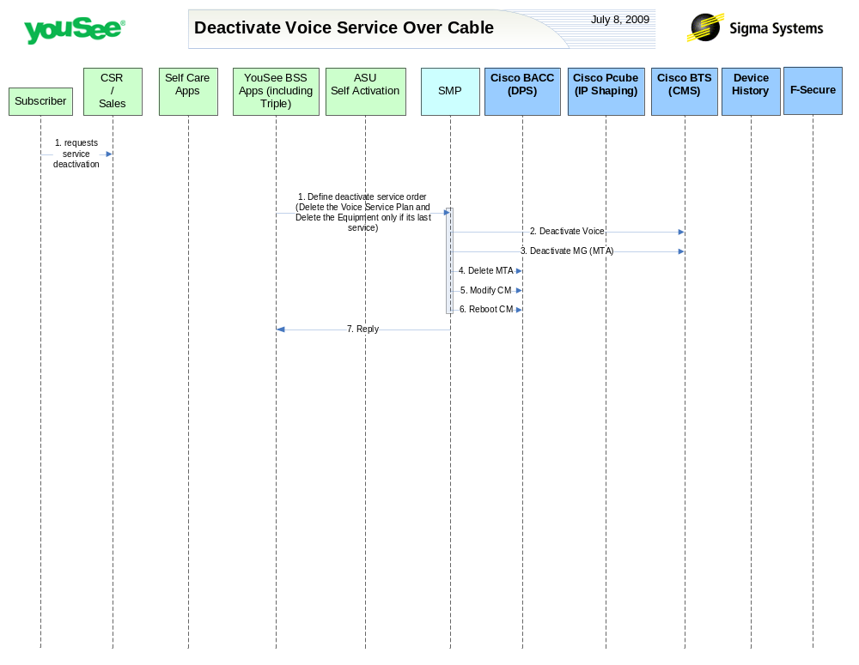

Primary Flow Detail
# | Actor: Key Action | Description | Alternate Flows/Details
 | YouSee BSS: Order is communicated to SMP | <As in Change service Order>
 | SMP: deactivates Voice Line from BTS | <As in Deactivate Broadband and Voice Service Use Case>
 | SMP: deactives MTA/MG from BTS | <As in Deactivate Broadband and Voice Service Use Case>
 | SMP: deletes MTA from BACC | <As in Deactivate Broadband and Voice Service Use Case>
 | SMP: modifies CM in BACC | SMP Will modify the CM configuration in BACC to enable broadband service but disable voice services
 | SMP: requests BACC to reboot the CM Device | Device is rebooted resulting in it receiving the new configuration
 | SMP: Replies back to ASU the status of Activation | SMP will reply to ASU the status of Provisioning Order to ASU. | If Provisioning fails then SMP will put the Failed task in Manual Queue.

